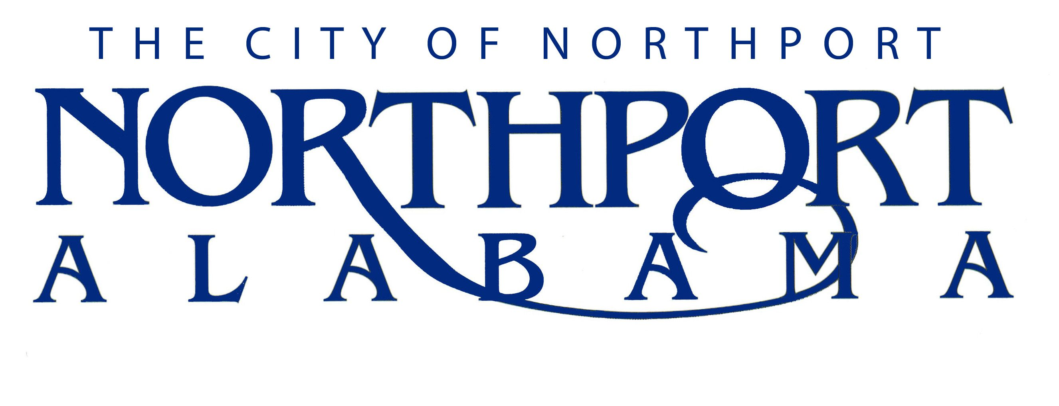

DIRECTOR OF PLANNING

Summary

Under general direction of the City Administrator, is responsible for planning and community development tasks including, but not limited to: Assisting in the development of the city’s comprehensive master plan; Managing the city's comprehensive master plan; Developing and applying the use of municipal zoning ordinances and subdivision regulations; Serving as the primary planning advisor; Supervising the activities of departmental personnel.

DUTIES AND RESPONSIBILITIES

- Operations (65%)

Manages and applies the concepts and principles of the city’s comprehensive plan and other approved planning directives.

Provides suggested revisions to the comprehensive plan or other planning documents and submits those to the City Administrator, City Council, Planning Commission and Zoning Board of Adjustment for review and consideration.

Routinely update the city’s planning documents including the comprehensive plan, land-use plan, zoning plans and ordinances, transportation and housing plans. Coordinates as necessary with city staff, elected officials and community leaders to facilitate the city’s planning directives.

Makes recommendations to a variety of groups on planning matters.

Reviews development proposals for conformity with principles of good planning and land use practices, for compliance with approved development regulations, and applicable laws and/or Northport municipal codes or ordinances.

Serves as the city’s primary planning staff member and advisor to the City Administrator, Mayor, Council, Planning and Zoning Commission, and Zoning Board of Adjustment.

Prepares department’s city council agenda business items.

Directs the coordination and preparation of agendas, site plan reviews, case files, and related
items for the Planning and Zoning Commission and Zoning Board of Adjustment.

Prepares and manages the department’s annual budget.

Attends all City Council, Planning and Zoning Commission, Zoning Board of Adjustment meetings and other meetings as directed by the City Administrator.

- Research (20%)

Researches the availability of Federal and State Grants and other sources of State and Federal funds for which the City is eligible.

Collects, organizes and maintains social, economic and census data for the use in planning studies and reports.

Investigates and responds to inquiries regarding planning activities.

- General (15%)

Coordinates staff reviews of all proposed developments including commercial,
industrial, retail, and subdivision developments to assure conformity with regulations, Northport
municipal code, and the City of Northport’s comprehensive plan.

Represents the city at community activities and events at public, social, and business gatherings as directed by the City Administrator.

Addresses civic, business and service organizations on public service matters regarding planning as directed by the City Administrator.

Develops departmental budget and submits the budget to the City Administrator.

Prepares slides and video presentations related to planning, zoning and community development.

Performs other duties assigned by the City Administrator.

JOB SPECIFICATIONS

Qualifications:

Bachelor’s degree in community planning, public administration or a related field required.

Master’s degree in community planning, public administration or a related field preferred.

Certification by the American Institute of Certified Planners (AICP) or other planning certification is preferred.

A minimum of five (5) years progressively responsible experience, including supervisory experience, in municipal, county or local government planning is required.

Must have a current driver’s license and have an acceptable driving record.

Excellent oral and written communication skills.

Must be able to successfully manage and accomplish multiple tasks.

Must be able to adjust to a constantly changing work environment.

Knowledge, Skills and Abilities:

Thorough knowledge of the environmental concerns related to Planning and Urban Development.

Thorough knowledge of the concepts of data base design, development, and application as related to comprehensive planning functions.

Knowledge of automated mapping principles and procedures.

Thorough knowledge of the current literature and recent developments in the field of municipal, county or local government planning.

Knowledge of legal and political processes as they apply to planning and community development.

Thorough knowledge of the advanced principles and practices of community planning.

Skills to appraise employee performance consistent with city policy, including counseling and resolution of individual employee performance problems.

Ability to organize many project activities simultaneously and keep on schedule and budget.

Ability to interpret and analyze technical and statistical information, and to prepare and present technical, oral and written reports.

Ability to develop policy and initiate ideas and recommendations.

Ability to translate goals and objectives into workable plans, programs, and activities.

Ability to use sound professional judgment in planning for future development.

Ability to research and prepare planning studies and to formulate substantive recommendations for planning standards and the development of overall city plans.

Ability to communicate well with the public and develop effective working relationships with the public and other employees.

Ability to maintain regular attendance on the job.

Physical Characteristics:

Hear well enough to carry on a normal conversation.

Effectively operate computer keyboard and other office machines.

Have ability to move freely about the office and ability to get into, operate and exit a motorized vehicle.

Have ability to sit or stand for long periods of time.

Must have willingness and ability to travel and remain away for consecutive days.

Must be able to write and speak English clearly.

